CASE FILE 11
Stride Watch
Product line: smartwatches
Stride Watch is a wearable-tech startup out of a Chicago incubator. Its first watch tried to do everything, and the reviews said it did nothing especially well.
Your job: Build a lineup of three versions, one for each segment below. For every version, choose its features and set its price. Your goal is the most total profit across all three.
THE MARKET: THREE SEGMENTS
Stride Watch surveyed people in the Chicago area. The survey split them into three groups. Read the profiles, then give each segment a name.
SEGMENT A  6,000 potential customers | SEGMENT B  12,000 potential customers | SEGMENT C  5,000 potential customers
- Runners and cyclists ages 16 to 45  - Trains for races and tracks every workout  - Hates charging a watch every night  “GPS or it didn't happen.” | - Ages 13 to 19, wants a first smartwatch  - Mostly cares about texts and notifications  - Changes bands to match outfits  “I want my texts without digging my phone out.” | - Ages 65 and up, often bought by an adult child  - Lives alone or walks alone daily  - Family wants to know they are safe  “My daughter wants to know I'm OK when I walk the dog.”
Our name for them: | Our name for them: | Our name for them:
PRODUCT BASICS
Base cost of every version | $30 per watch, before any features are added
Price options | $60 $90 $130 $180 $250 $330 (each version must use one of these prices)
WARM-UP: READ THE DATA FIRST
1. Which segment has the most must-have features (60% or higher)? How many does it have?

2. What is the most expensive feature on the menu? Which segment, if any, says it is a must-have?

3. What is the lowest price at which fewer than half of Segment B would buy?

4. If Stride Watch sold a version with a Fit of 100% to Segment A at $180, how many people would buy it?

SURVEY RESULTS: WHAT EACH SEGMENT REQUIRES
Question asked: “Which of these would a smartwatche need to have before you would buy it?”
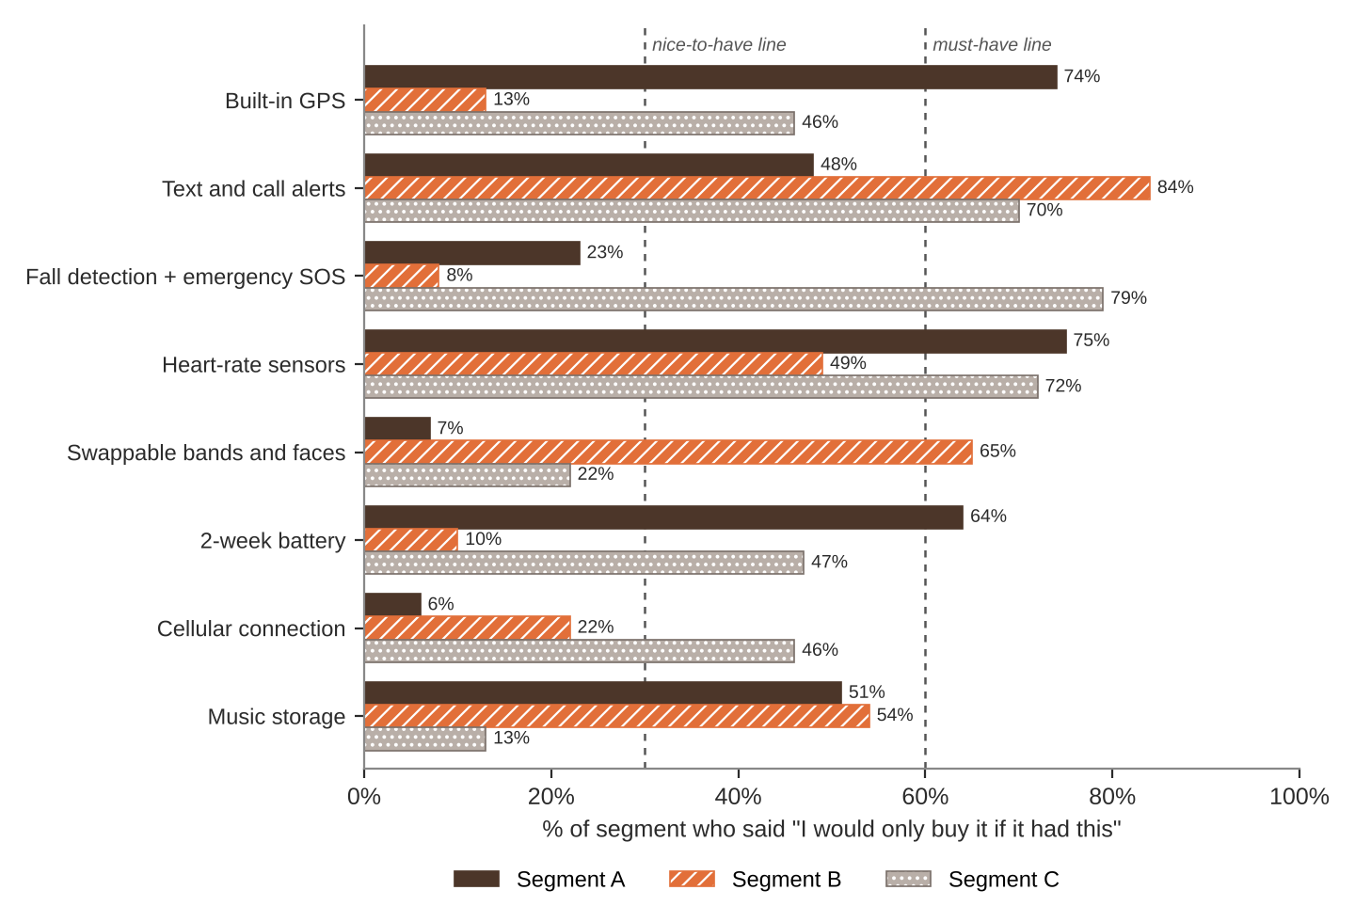
FEATURE MENU
Every feature you add raises your cost per watch. Add a feature to any version you want.
Feature | What it is | Cost to add
Built-in GPS | Tracks routes and distance without a phone | $12
Text and call alerts | See messages and calls on your wrist | $4
Fall detection + emergency SOS | Calls for help after a hard fall | $9
Heart-rate sensors | Heart rate and blood oxygen tracking | $10
Swappable bands and faces | Dozens of bands and watch faces | $3
2-week battery | Charge twice a month | $8
Cellular connection | Works without a phone nearby | $25
Music storage | Store playlists on the watch | $6
SURVEY RESULTS: WHAT EACH SEGMENT WILL PAY
Question asked: “If it had everything you need, would you buy it at this price?”
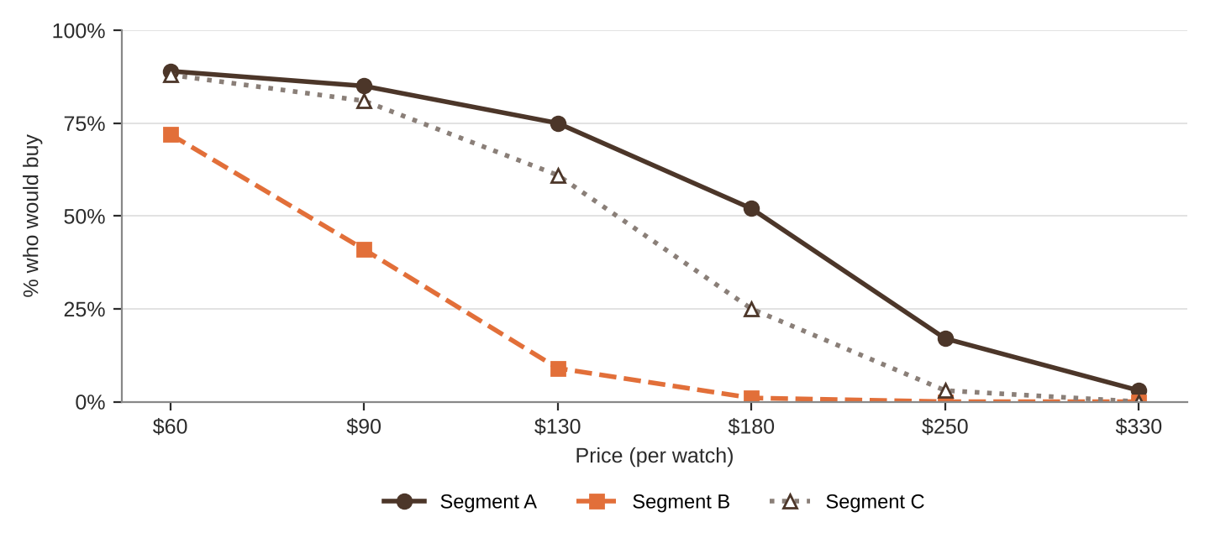
% of each segment who would buy at each price
Price | $60 | $90 | $130 | $180 | $250 | $330
Segment A | 89% | 85% | 75% | 52% | 17% | 3%
Segment B | 72% | 41% | 9% | 1% | 0% | 0%
Segment C | 88% | 81% | 61% | 25% | 3% | 0%
QUICK RULES
Must-have | A feature that 60% or more of a segment requires. Leave one out and that segment's buyers are cut in half. Leave two out and they're cut in half again.
Nice-to-have | A feature that 30% to 59% of a segment requires. Each one you include adds 5% to Fit.
Under 30% | That segment doesn't care. It adds cost and nothing else.
Fit | Start at 100%. Add 5% for each nice-to-have included. Then cut in half for each must-have left out.
Buyers | Segment size × % who would buy at your price × Fit. Round to a whole number.
Profit | Buyers × (Price − Unit cost). Unit cost = base cost + cost of every feature you added.

